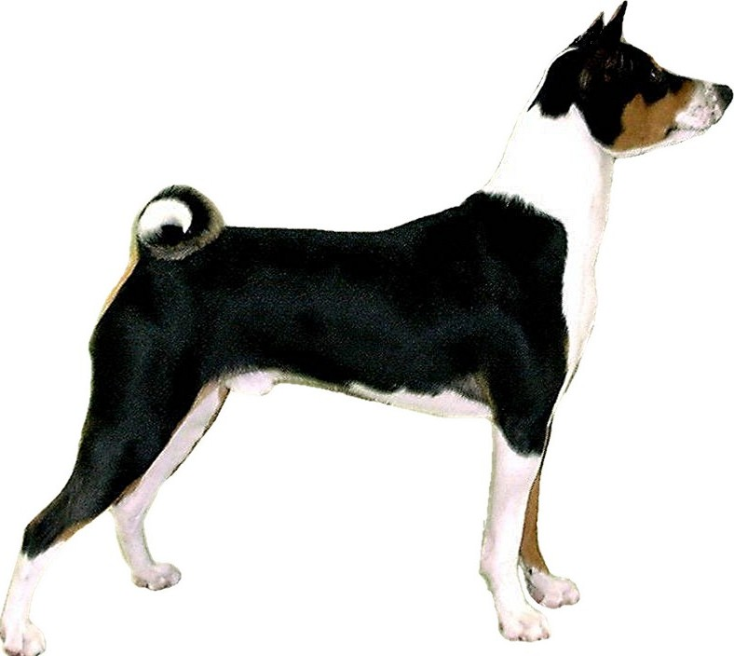
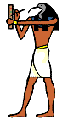
Baraka Basenji
Paul and Bill Bowlus-Root
Phone: 425.576-8177
Email: BRINC@brincnet.com
www.barakabasenji.com
7611 128th Place NE
Kirkland, WA 98033

Puppy Placement Questionnaire
Thank you for your interest in acquiring a puppy from Baraka Basenji. Please be aware that placement decisions will not be made before the puppies are eight weeks old and are usually finalized by their tenth week. During this time, you are welcome to make arrangements with us to visit the puppies and interact with them.
Baraka Basenji
Paul and Bill Bowlus-Root
Phone: 425.576-8177
Email: BRINC@spro.net
www.barakabasenji.com
7611 128th Place NE
Kirkland, WA 98033

Our primary concern when placing puppies is the long-term health and welfare of the dogs. It is important to us that our puppies will be loved and well-cared for, and that the people we place them with have the resources and knowledge to raise a happy and healthy Basenji. To that end, we are committed to establishing a long-term supportive relationship with any family we place a puppy with, providing training and consultation for issues arise over the lifetime of the dog.

There are many factors to consider when placing the few puppies we have in any given litter. Each puppy must be matched according to its own needs and temperament with a new owner capable of supporting that puppy. Often we must choose from a list of many fine and well-suited candidates. So, if you are not selected to receive a puppy this time, please do not take offense or think that you were judged as being in some way ‘unworthy’. It’s entirely possible that we may consider you when future litters are available or we may be able to refer you to other breeders.

The Basenji is an ancient breed of dog with unique characteristics and behavior patterns unlike other breeds. Living with a Basenji can be a rewarding experience when the home environment and lifestyle of the owner are a good match – or a nightmare when they are not. It is in everyone’s best interests to ensure that puppies are placed in homes well-suited to their peculiarities and prepared for the challenges of raising a healthy Basenji. We appreciate your help to determine whether there is a ‘good fit’ in your case by filling out and returning this questionnaire.

Thanks again for your interest,

Paul and Bill Bowlus-Root
Baraka Basenji

Please supply the following information. The questionnaire can be completed in various ways:
1) Print this page of the form, fill it in by hand, and then return the completed form to us through regular mail, or
2) Fill-in the form fields directly in Word and save it, and then either a) send the saved .DOC file to us in email or b) print the completed form and send it to us via regular mail.
First and Last Name(s):
Mailing Address:
Preferred Phone Number and Type: |  |  | Best Time to Call:
Preferred Email Address:
Marital Status:
Age(s) of Adults in the Home: |  | Occupation(s):
Number of Children in the Home: |  | Ages:
How many daytime hours is at least one person at home? |  | Does anyone in the home have allergies?
Home Type and Ownership: |  |  | Square Footage:
Yard Type: |  | If “Fenced”, fence type and height:
Neighborhood Type:
 | Breeds | Ages | Genders | Intact/Altered
Other Dogs in the Home:
Are there cats in the home? |  | If so, how many?
List Other Pets in the Home:
Where would you keep the dog?
Have you previously owned a Basenji?
What is it about the Basenji breed attracts you?
What books have you read about Basenjis?
What web resources have you investigated?
What gender are you looking for?
What color(s) are you looking for? | Red & White | Black & White | Tri-Colored | Brindle
What quality are you looking for? |  | Do you intend to breed this dog?
How were you referred to us?
Is there anything else we should know about or be aware of?
This form is for the collection of information for evaluation only and should in no way be construed to represent a contract, warranty, guarantee, or agreement of any sort.
The information you supply on this form may be used by Baraka Basenji and our breeding partners for evaluative purposes only. It will be held in strict confidence and not shared with any party without your prior written consent.
Copyright © 2006-2012, Baraka Basenji

